**Exercise 2: Error Handling**

**Scenario 1:** Handle exceptions during fund transfers between accounts.

* **Question:** Write a stored procedure **SafeTransferFunds** that transfers funds between two accounts. Ensure that if any error occurs (e.g., insufficient funds), an appropriate error message is logged and the transaction is rolled back.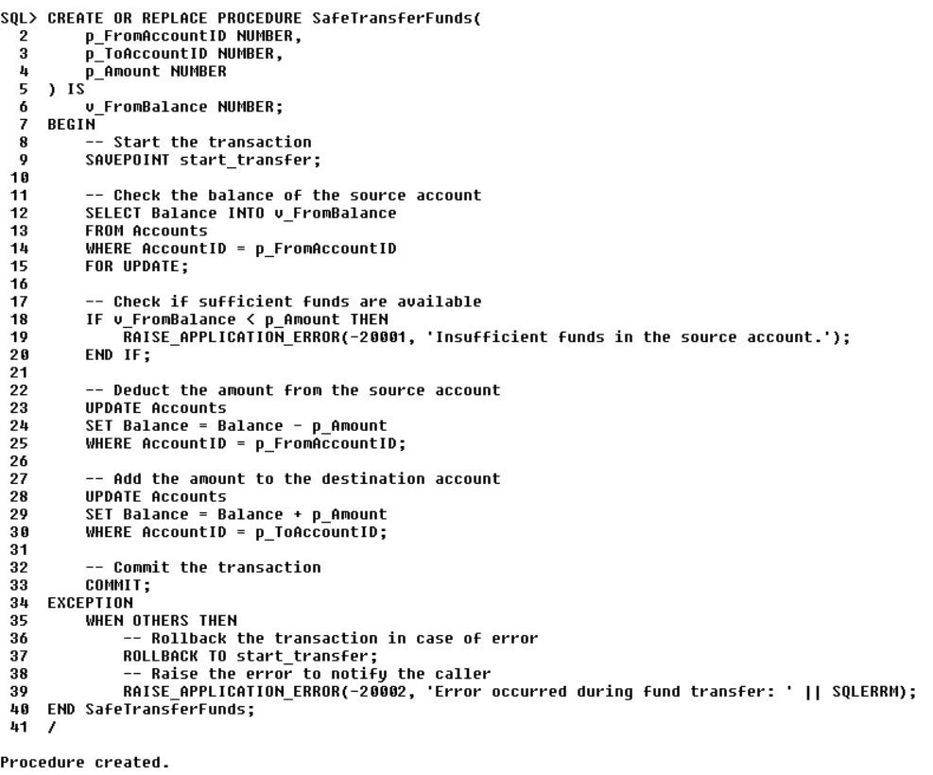  
  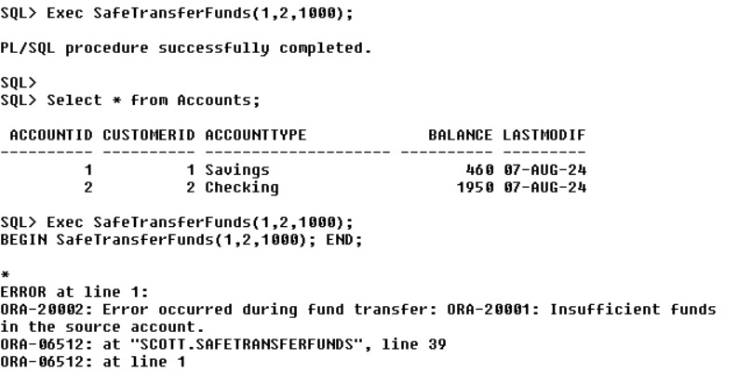

**Scenario 2:** Manage errors when updating employee salaries.

* + **Question:** Write a stored procedure **UpdateSalary** that increases the salary of an employee by a given percentage. If the employee ID does not exist, handle the exception and log an error message.

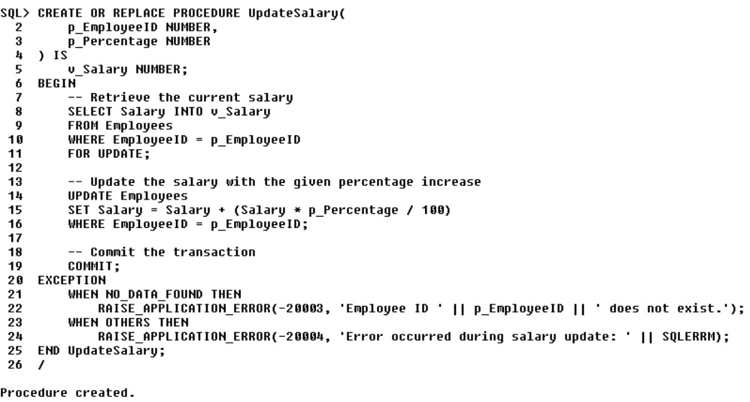  
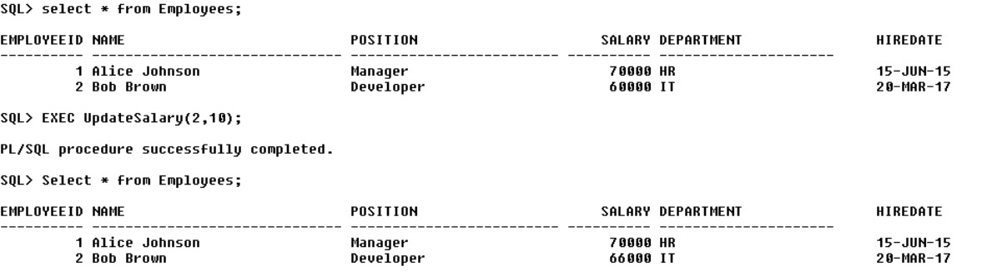

**Scenario 3:** Ensure data integrity when adding a new customer.

* **Question:** Write a stored procedure **AddNewCustomer** that inserts a new customer into the Customers table. If a customer with the same ID already exists, handle the exception by logging an error and preventing the insertion.  
  